Online Movement Evaluation
For all movements
The camera needs to see your whole body
Wear loose fitting workout clothes that do not restrict movement
Barefoot is preferable (if not wear your normal athletic shoes)

For video compression and analysis purposes, please record and email each video individually
Movement | Camera View Required | Description | Image
Overhead Squat | Front and side views  -2 reps facing the camera  -2 reps from a side view  (either side) | -Place towel in hands overhead  -Feet shoulder width apart  -Squat down as far as possible and return to starting position | 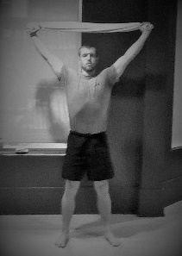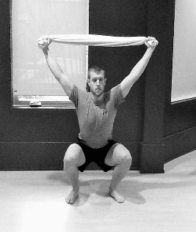
Hurdle Step | Front view only  -2 reps with LEFT leg marching  -2 reps with RIGHT leg marching | -Stand as tall as possible while grasping a towel across your shoulders  -Step over an imaginary fence that is knee height  & tap foot to the ground over the fence  -Step back over the fence | 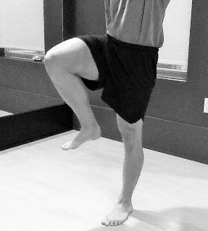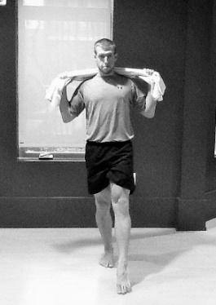
Inline Lunge | Front and Side view  -1 reps with LEFT leg forward facing the camera  -1 reps with RIGHT leg forward facing the camera  -1 reps with LEFT leg forward from a side view  -1 reps with RIGHT leg forward from a side view | -Start in lunge position with feet in the same plane approx. 1.5 feet apart  -Towel resting taut in arms across your shoulders  -Lower back knee into a lunge position  -The back heel will raise and the front will remain on the ground | 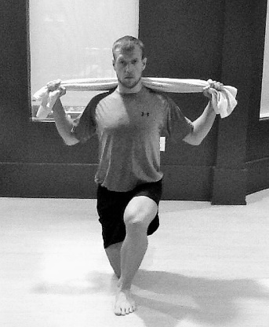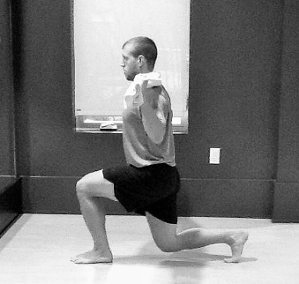
Shoulder Reach | Face away from the camera  -1 rep with RIGHT arm reaching overhead and let your fist rest on your back. Reach LEFT hand around back and slide fist up toward opposite hand  -1 rep with LEFT arm reaching overhead and let your fist rest on your back. Reach RIGHT hand around back and slide fist up toward opposite hand | -Keep fists closed during the movement  -Perform each movement in a smooth controlled manner | 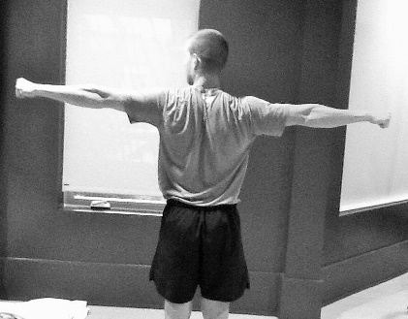  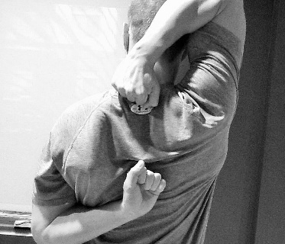
Straight Leg Raise | Side view only  -1 rep lying down lift LEFT leg into air as high as possible  -1 rep lying down lift RIGHT leg into air as high as possible | -While lifting one leg, keep the opposite leg on the ground | 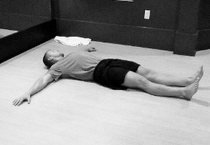  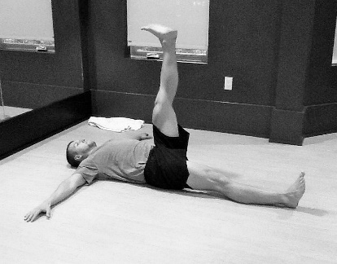
Push up | Side view only  -Perform 2 reps while attempting to move the body as one unit | -Bring hands shoulder width apart  -Slide hands up to eye level  -Move the whole body as 1 unit | 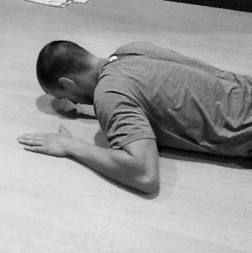  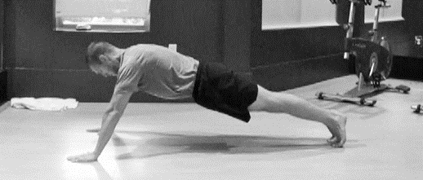
Bird dog | Side view only  -2 reps kicking LEFT leg back and RIGHT arm forward  -2 reps kicking RIGHT leg back and LEFT arm forward | -Start in a neutral table top position on all 4’s  -Reach opposite arm and leg outward, then touch leg in midline | 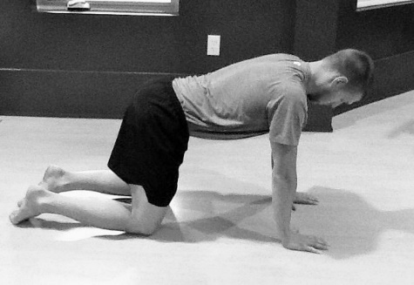  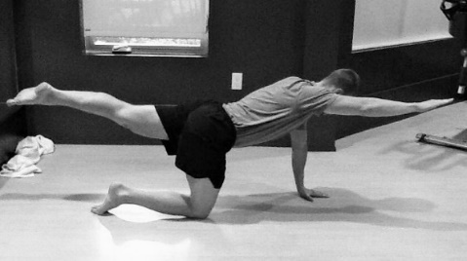  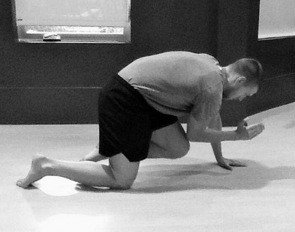

*If you have pain with any movement, stop the test! Please seek a medical practitioner to evaluate the pain. If you are having pain you are not an appropriate candidate for the screening*

